JSON

🧾 What is JSON?
# Source: AI Source: Provided by: [Data Path: Persons Table -> ID Column: 1, Name_En Column: Motasem Essam] -> From: [Chatgpt (GPT‑5 Mini)] on [1/26/2026]
JSON stands for JavaScript Object Notation.
It’s a lightweight, text-based data format used to store and exchange data — easy for humans to read and easy for machines to parse and generate.

🧠 Key Idea:
# Source: AI Source: Provided by: [Data Path: Persons Table -> ID Column: 1, Name_En Column: Motasem Essam] -> From: [Chatgpt (GPT‑5 Mini)] on [1/26/2026]
JSON represents structured data using key–value pairs, arrays, and nested objects — much like how data is used in programming languages.

📦 JSON Example:
# Source: AI Source: Provided by: [Data Path: Persons Table -> ID Column: 1, Name_En Column: Motasem Essam] -> From: [Chatgpt (GPT‑5 Mini)] on [1/26/2026]
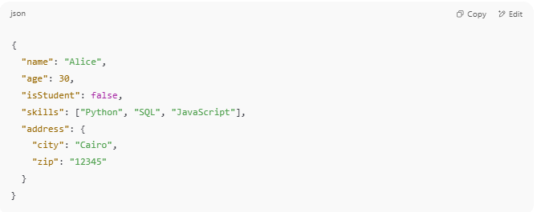
{
"name": "Alice",
"age": 30,
"isStudent": false,
"skills": ["Python", "SQL", "JavaScript"],
"address": {
"city": "Cairo",
"zip": "12345"
}
}

✅ Human-readable
✅ Machine-parsable
✅ Used by APIs, databases, config files, and more

📌 JSON Data Types
# Source: AI Source: Provided by: [Data Path: Persons Table -> ID Column: 1, Name_En Column: Motasem Essam] -> From: [Chatgpt (GPT‑5 Mini)] on [1/26/2026]
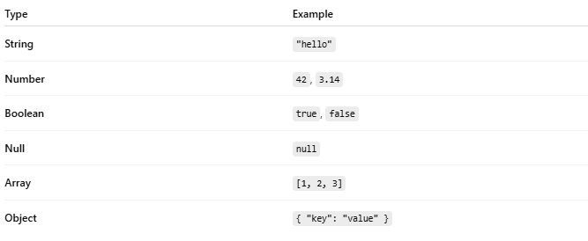
Type | Example
String | "hello"
Number | 42, 3.14
Boolean | true, false
Null | null
Array | [1, 2, 3]
Object | { "key": "value" }

🔁 JSON vs JavaScript Object
# Source: AI Source: Provided by: [Data Path: Persons Table -> ID Column: 1, Name_En Column: Motasem Essam] -> From: [Chatgpt (GPT‑5 Mini)] on [1/26/2026]
- JSON syntax is based on JavaScript objects
- But JSON:
  - Only allows double quotes for strings
  - Doesn't allow comments
  - Only supports specific data types

📡 Where Is JSON Used?
# Source: AI Source: Provided by: [Data Path: Persons Table -> ID Column: 1, Name_En Column: Motasem Essam] -> From: [Chatgpt (GPT‑5 Mini)] on [1/26/2026]
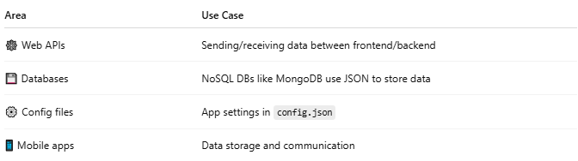
Area | Use Case
🕸️ Web APIs | Sending/receiving data between frontend/backend
💾 Databases | NoSQL DBs like MongoDB use JSON to store data
⚙️ Config files | App settings in config.json
📱 Mobile apps | Data storage and communication

🔧 JSON in Code (Examples)

✅ JavaScript
# Source: AI Source: Provided by: [Data Path: Persons Table -> ID Column: 1, Name_En Column: Motasem Essam] -> From: [Chatgpt (GPT‑5 Mini)] on [1/26/2026]
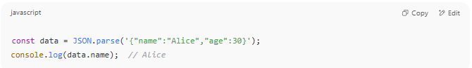
const data = JSON.parse('{"name":"Alice","age":30}');
console.log(data.name); // Alice

✅ Python
# Source: AI Source: Provided by: [Data Path: Persons Table -> ID Column: 1, Name_En Column: Motasem Essam] -> From: [Chatgpt (GPT‑5 Mini)] on [1/26/2026]
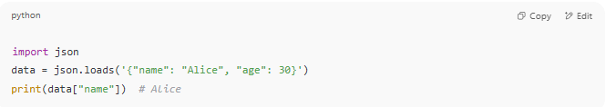
import json
data = json.loads('{"name": "Alice", "age": 30}')
print(data["name"]) # Alice

❗ Common Mistakes
# Source: AI Source: Provided by: [Data Path: Persons Table -> ID Column: 1, Name_En Column: Motasem Essam] -> From: [Chatgpt (GPT‑5 Mini)] on [1/26/2026]
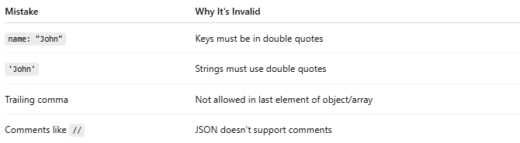
Mistake | Why It's Invalid
name: "John" | Keys must be in double quotes
'John' | Strings must use double quotes
Trailing comma | Not allowed in last element of object/array
Comments like // | JSON doesn’t support comments

🆚 JSON vs XML
# Source: AI Source: Provided by: [Data Path: Persons Table -> ID Column: 1, Name_En Column: Motasem Essam] -> From: [Chatgpt (GPT‑5 Mini)] on [1/26/2026]
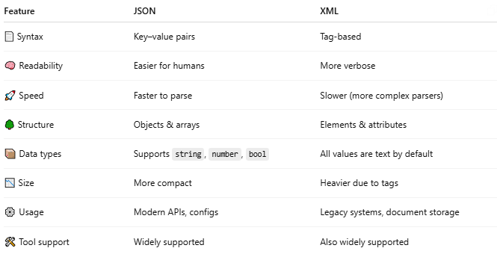

Feature | JSON | XML
📄 Syntax | Key–value pairs | Tag-based
🧠 Readability | Easier for humans | More verbose
🚀 Speed | Faster to parse | Slower (more complex parsers)
🌳 Structure | Objects & arrays | Elements & attributes
📦 Data types | Supports string, number, bool | All values are text by default
📉 Size | More compact | Heavier due to tags
⚙️ Usage | Modern APIs, configs | Legacy systems, document storage
🛠️ Tool support | Widely supported | Also widely supported

JSON is now the preferred format in most web and app development, but XML is still used in complex or legacy systems.

🔁 SQL ↔ JSON Conversion

✅ SQL Table Example:
# Source: AI Source: Provided by: [Data Path: Persons Table -> ID Column: 1, Name_En Column: Motasem Essam] -> From: [Chatgpt (GPT‑5 Mini)] on [1/26/2026]
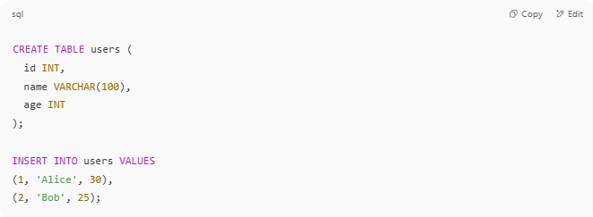
CREATE TABLE users (
id INT,
name VARCHAR(100),
age INT
);

INSERT INTO users VALUES
(1, 'Alice', 30),
(2, 'Bob', 25);

🔄 Convert to JSON:
# Source: AI Source: Provided by: [Data Path: Persons Table -> ID Column: 1, Name_En Column: Motasem Essam] -> From: [Chatgpt (GPT‑5 Mini)] on [1/26/2026]
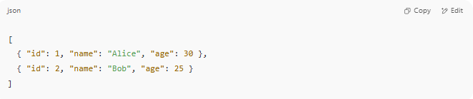
[
{ "id": 1, "name": "Alice", "age": 30 },
{ "id": 2, "name": "Bob", "age": 25 }
]

🔄 Convert JSON to SQL:

JSON:
# Source: AI Source: Provided by: [Data Path: Persons Table -> ID Column: 1, Name_En Column: Motasem Essam] -> From: [Chatgpt (GPT‑5 Mini)] on [1/26/2026]
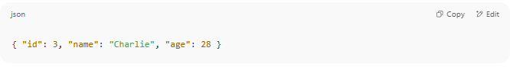{ "id": 3, "name": "Charlie", "age": 28 }

SQL:
# Source: AI Source: Provided by: [Data Path: Persons Table -> ID Column: 1, Name_En Column: Motasem Essam] -> From: [Chatgpt (GPT‑5 Mini)] on [1/26/2026]
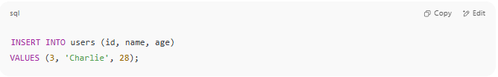
INSERT INTO users (id, name, age)
VALUES (3, 'Charlie', 28);

✅ JSON fits row-like data well, making it perfect for exporting/importing between SQL and NoSQL systems.

✅ Summary
# Source: AI Source: Provided by: [Data Path: Persons Table -> ID Column: 1, Name_En Column: Motasem Essam] -> From: [Chatgpt (GPT‑5 Mini)] on [1/26/2026]
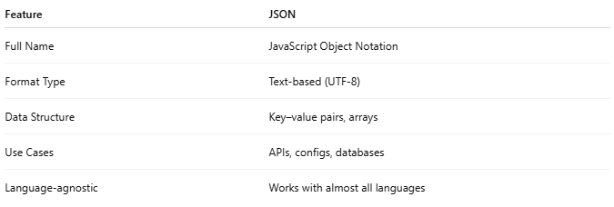
Feature | JSON
Full Name | JavaScript Object Notation
Format Type | Text-based (UTF-8)
Data Structure | Key–value pairs, arrays
Use Cases | APIs, configs, databases
Language-agnostic | Works with almost all languages

